Own Arrangement Services on Prayer

A. Introduction
The aim of these notes is to enable congregations and those organising Own Arrangement services to explore prayer through acts of worship. Worship usually includes singing, talking and praying, plus other audio and visual items (flowers, pictures, music, tableaux), which can be combined in limitless ways, helping us relate to God as Father. Here, we’re focus chiefly on services about prayer, but in the setting of worship. No off-the-peg examples of services are provided. Instead, congregations and individuals are encouraged to pursue voyages of discovery.

B. What prayer is and how you do it
Prayer is communicating with God. It’s two-way – listening as well as speaking to one unseen, as on the phone. The type of conversation depends on what we think of God, and our current circumstances and feelings. If what we want to talk about is not too private, it’s good to do it with others who share our faith. It gives great power and a sense of togetherness. But some things are more personal. Nothing is too personal to share with God, but we may not want to share everything with others, even other believers. It’s wise to remember this in creating a service of worship.

1. How do you pray: out loud or inside?
If you want others to join in, as in public prayer, you pretty well have to use words out loud. In private prayer, including that in church, you can think your words (like reading to yourself) because God knows what’s in our hearts. Incidentally, even though he does know our hearts, he still delights when we pray. But however we express our prayers, remember not to do all the talking: listen as well.

2. Is there a special prayer language?
Anyone can talk with God, and therefore you don’t need special words or language to pray in private or public (you really don’t!), but church history makes clear that some people are gifted with an ability to express public prayers in language that listeners find uplifting and helpful in their own prayers. The book of common prayer is the classic example, but you can also sing prayers, as in some hymns and songs. If you have been so gifted, even in a small way, then God will be delighted to hear you use his gift, and congregations will be blessed.
Whatever your gifting with words, however, it helps to have a good attitude:
- Reverence for the holy God who invites us to pray to him (or with him)
- A sense of depending on the loving Father who made us and cares for us
- Trust in his promises to meet all our needs through Jesus
- Alertness to the guidance of the Holy Spirit, who empowers and enables.

3. What should we pray for?
The basic model of prayer is the Lord’s prayer, but it may be worth listing different sorts of prayer.
- It’s always good to praise God, reminding ourselves of his greatness and other attributes, and passages of Scripture which do this can be helpful sources of inspiration.
- When we’re aware of things we’ve done wrong (or failed to do right) we can confess our sins, or general sinfulness, and thereafter be reassured that God forgives those who repent – i.e., turn away from wrongs and back to him.
- Forgiveness leads to thankfulness. We can thank God for all his blessings. But we can go further: we can thank him for his promise to see us through hard times (and even for the hard times themselves, because he can use them for building us up).
- We can ask for help in following his will and working in his kingdom. We can pray for ourselves, and we can intercede for others: for an end to problems or the strength to weather them, and for Christian fidelity and fruitfulness – despite sickness, hassles, confusions, discouragements, and distractions, (or whatever).
These are sometimes called Adoration, Confession, Thanksgiving and Supplication, or ACTS for short.

C. Putting together a service of worship
It’s traditional to have hymns interspersed with readings and prayers, talks, etc. (radio chat shows do something similar, even if the content differs). You don’t have to follow this format: e.g., some traditions put all the hymns together in a time of singing. Remember you’re preparing a service of worship to God, and thus it is entirely appropriate to ask him how he would like to be worshipped on this occasion – though he may expect you also to pay due heed to the expectations and preferences of the congregation. Listen for the Spirit’s guidance as you choose the bits and put them together.

1. A theme
Although the service is about prayer, you might choose to major on one or more aspects of that broad subject (see above), or you might want to apply prayer to a particular aspect of Christian life or kingdom work: e.g., persecution, or mission, or healing, or a local project, or a concern, etc.

2. Bible readings
The Bible has lots to say about prayer, with many examples of people praying in diverse situations, and of course, God’s answers (most important). The Bible is always a good place to begin, because it is God’s word to us. Here are some ways into Bible passages on prayer:
- The Lord’s prayer (Mt 6:9ff; Lk 11:2ff)
- The Lord’s practice in prayer (e.g., sometimes taking himself off alone – Mk 1:35)
- Paul’s prayers in his letters, usually near the beginning, though see also Eph 3:14ff; 6:18f.
- Look up in a concordance words like: Pray, Praise, Thank, etc. (see Resources below)
- Choose a Bible book or letter and see how prayer is used throughout.
- Follow a particular intercessor , e.g., Moses (Ex 33:12ff), Elijah (Jas 5:17f; 1 Kings 18–19, esp. 18:41ff), Nehemiah; Habakkuk.
- Take God’s promises in Scripture and pray them into being, e.g., like Acts 4:23-31.
- Many Psalms contain wonderful prayers – public, but astonishingly intimate. You can use them as they stand, or adapt them to your own circumstances, allowing them to lead your thoughts as you speak with God. For instance:
4:1 – with its three lines, each of which can be pondered and extended
6:1-3 – expressing longing and (oh, so common with us too) impatience for God’s answer
8 – thoughts of wonder to the Creator (applied to Jesus in Heb 2:5ff)
19 – marvelling at God’s creation and his written word
23 – trust, leading on to commitment
51 – the classic psalm of penitence, with forgiveness
139 – marvelling at God’s omniscience in relation to human existence and activity
and so on ...

3. Hymns and songs
These guidance notes aim to help you discover hymns and songs which fit the occasion for your church, and therefore they resist the temptation to suggest actual examples. That’s irritating if you really don’t know where to begin, so here are some ideas to help you grope in the right direction.

(a) Looking at hymn books
Hymn books contain several selections on prayer (e.g., praise, confession, petition, intercession, thanksgiving, etc.). These include songs about prayer, or are sung prayers. From the hymns listed in the sections on prayer, select some which are good to sing and have words that fit your theme. Here, for instance, is some guidance for three commonly used books:
Hymns & Psalms (in III. God’s People – B. The Worshipping people)
- Praise and adoration 484 – 516
- Confession and Supplication 517 – 544
- Petition and Intercession 545 – 560
- Thanksgiving 561 – 574

Singing the Faith (in God’s Enduring Purposes)
3. The Adoration of God 39 – 59
4. Praise and Thanksgiving 70 – 98
26. Prayer: Intercession and Petition 517 – 531 (and other places)
Mission Praise: Hymns are listed mainly in alphabetical order of the first line (though each edition has added a new selection at the end, so the overall index of first lines is still needed), but in the music edition there is a Subject Index at the back. E.g., in Section D: Living the Christian Life, there are the following lists – though your choice need by no means be restricted to these. (If you don’t have a music edition, you can work from http://www.missionpraise.com/fullindex.)
D1. Praise and Thanksgiving
D4. Worship and Adoration
D5. Confession and Repentance
D7. Prayer
D13. Guidance
D14. Comfort, Strength and Security
D15. Health, Healing and Deliverance
D16. Trials and Temptations
D17. Spiritual Warfare

(b) Hymns for different parts of the service
If you choose to follow the normal Methodist service format, the following guidance may help.
Opening hymn: One that draws people in and lifts their hearts and minds to worship God. Perhaps a hymn of praise to God for his greatness might be suitable
Closing hymn: Perhaps one that sends everyone out encouraged and stirred to keep faith with God and pray in the week ahead. Something on commitment might be appropriate.
Other hymns: Suit the choice of hymn to that bit of the service – noting the preferences of the congregation (from rock to Bach). Have a bit of variety. If there are children present, make sure that at least one is specifically for them. (Some hymn books list children’s hymns.)

(c) Linking hymns with Scripture
Sometimes you may want to have a hymn which ties in with a particular Bible reading, and some hymn books include (in the music versions) comprehensive Bible reference indexes. Hymns & Psalms and Singing the Faith both have such indexes, but (sadly) not Mission Praise.

(d) Congregational requests
Another possibility entirely is to invite the congregation to choose their own hymns – with notice, unless the musician is happy to sight read.

4. The talk
Because these notes are intended to help you put together an Own Arrangements service, it probably isn’t possible to have a sermon as such – for which Methodism normally requires an accredited preacher. You can give a less formal talk, address, or homily, but there are lots of other possibilities, including:
- Read something published about prayer (not necessarily a published sermon).
- Invite testimonies about prayer from members of the congregation. It’s probably best to arrange this in advance, with just one or two, and perhaps with a time limit.
- Favourites snippets (all on prayer) contributed by the congregation: Reflections, readings, poems, stories, songs from a CD (comply with copyright).
- Have a discussion on some aspect of prayer – break the congregation up in some way unless it’s quite small, e.g.: turn your neighbour; forms threes; groups in each corner of the church. Possibly with report back.
- Role play on prayer. Use your imagination.

5. Ideas for prayer in services
It’s valuable to talk about prayer, but no service of worship is complete without actual prayer, especially (of course) a service on prayer. We want to enable each person to pray for themselves, yet as part of the whole congregation – and to learn to go on praying even when the service is over.

(a) Written prayers
For the inexperienced it may be hard to find the words to pray out loud in front of others. There’s a need for coherence which doesn’t apply in our own thoughts with God. One way round this is to use published prayers where someone has found the words for you – e.g., from Methodist Worship Book, the Methodist Prayer Manual, or the many other books available; or search the web; or ask people for their favourites. See also Resources at end.
Alternatively, you or others in the congregation can use your own prayers written out beforehand. John Pritchard’s book The Second Intercessions Handbook has many creative ideas to help you, and if you can be a bit adventurous in the choice of both words and images, this can be a good way of stimulating imaginations, thus leading people into fresh ways of praying. E.g., beginning: Lord of the schedules of time...; Lord of the store cupboard of abilities...; Lord of the reservoirs of energy...; Lord of the cosmic rescue package...; etc.
However, reading written prayers can sound a bit formal or artificial unless you read well, which is one reason why many prefer more spontaneous forms of prayer.

(b) Extempore or free prayer
Instead of reading written prayers, you can just speak to God extempore – i.e., as the words come to you. This has the advantage of immediacy and intimacy but, although some are gifted in this way, it doesn’t always come easily – and even when it does there may be a need to exercise discipline because the person who prays does so on behalf of the whole congregation. Thus even if the prayers are not written out, they should almost certainly be given some prior thought. Such prayers can arise from a Bible text (e.g., Psalm) or a hymn, or reflect a need, express praise and thankfulness, or whatever.
You can have a time of free prayer, with anyone free to pray. This requires participation and cooperation, and can greatly enrich the prayer time. Encourage people to be brief (to prevent rambling) and to tackle only one topic at a time, i.e., not to try to cover everything all at once. It’s good if they can also be audible, which can be a problem when people bow their heads, and a closing ‘Amen’ lets others know you’ve finished and they can begin.
One rather chaotic-sounding suggestion is to encourage everyone in the congregation to pray out loud all at the same time. God can doubtless decipher, but few may feel that this is ‘doing everything decently and in order’.

(c) Led or themed prayer
It may help everyone if you follow themes, rather than jumping to something fresh each time.
- A leader may guide the prayers, mentioning a theme and giving time to follow it before moving on to the next one.
- Take the Lord’s prayer line by line, with pauses in between, for silent or spoken prayer, as individuals feel led by the Spirit.
- Work through your church newsletter or magazine, praying for concerns and coming events.
- Prayer suggestions from the congregations, written out on slips of paper and gathered in: these can be grouped and prayed about.
Leaders must exercise gentle sensitivity, in knowing how long to wait, and when to move on to the next topic, and not making people feel vulnerable – because some may be uncomfortable, either with praying out loud at all in a church service, or with sharing personal prayers – we all have our secrets, pride, modesty and uncertainties.

(d) Times of silence
Some people find it very helpful to have a time of silence (with or without quiet music), for their own thoughts and prayers, and for an opportunity to listen for God’s responses. But be careful: on the one hand don’t be too short – give people time to get their minds in gear; on the other hand too long a silence can make people feel uncomfortable. So tell them how long the silence will be, approximately (and stick to it!), and even suggest what they may do or think about, or gently offer guidance from time to time, or give them something to look at.

(e) Symbols to help prayer
Some things – call them ‘symbols’ – can focus or stimulate thoughts on prayer, though not everyone likes them. Even for those who do, it’s usually beneficial if the symbols can be explained a little by those who choose them or create them. Or perhaps the congregation could be invited to share what they see in them once they are displayed. Symbols for prayer might include:
- A lit candle.
- Flower arrangements. The slogan, ‘Say it with flowers’ is catchy, but their message may nevertheless need spelling out a bit.
- Music pieces, evocative of prayer.
- Actions to signify prayers offered, e.g.: place or drop a marble or a stone in a bowl (perhaps full of water) for each prayer; pin a written prayer on a tree or the cross; light and place tea lights somewhere at the front; etc.
- Invite members of the congregation to bring something (and say a few words about what it means to them about prayer).
- A picture, or banner.
- Other objects, singly or arranged.
Below are two illustrations of how you might use an arrangement of objects or a picture:
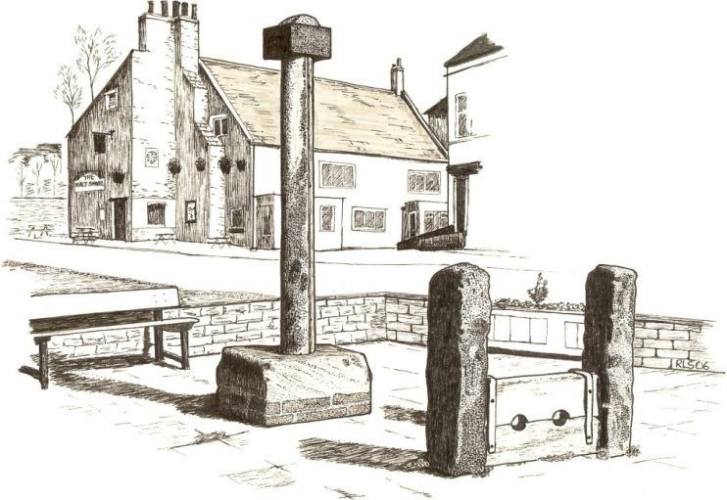
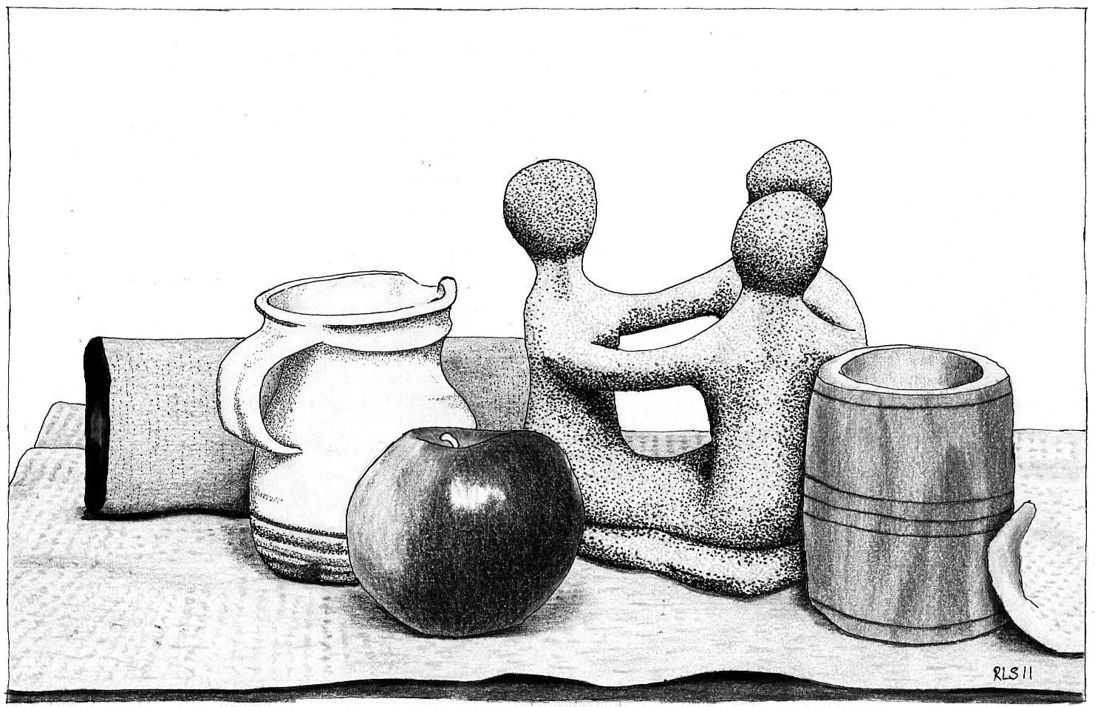
Arranged objects. Select objects which might have something to say about prayer, e.g.: a jug (being poured out); statuette (prayer triplet); wooden container (being made more useful); an apple (fruitful..., or obedience..., or repentance/forgiveness) – this last example indicates that it’s quite OK if people’s take on the various objects differs widely. The purpose is not to teach a lesson but to get thoughts (and prayers) flowing freely.
Picture with symbolic ‘meaning’. You might reflect on: the stocks and how sin holds us captive; the old market cross could symbolise the liberation through Jesus (better if it actually looked like a cross!); the more comfortable bench on the far side is like Christ’s easy yoke; and this all happens within the (living) walls of the church; but from that necessary beginning we must venture forth into the world – the street, by the shops and houses and pubs...
Each aspect can evoke prayer: those mentioned plus any others that occur to you.
However, and finally, some of the most powerful symbols are pictures in the mind created by words, above all by God’s Word. In worship we are invited to come boldly to the heavenly throne of grace where, through Jesus, we can ask for help in times of need (Heb 4:14-16), and John sees that approach to the throne by 24 elders and four living creatures (Rev 4). If the elders in some sense represent the church, the creatures can symbolise our prayers: the lion for their raw power in the name of Jesus (the Lion of Judah); the ox for steady, obedient prayer-work leading surely to harvest; the human face signifying prayer of perceptive intelligence to combat the foe; and the eagle in flight soaring, seeing and swooping behind enemy lines with prayer which no gates can exclude. Small wonder that both elders and creatures worship before the throne, where we of all ages may join them.

D. Resources
Your need for and use of resources will vary according to the type of person you are and the gifts God has given you. He has gifted some to be librarians and archivists, and they can assemble published material. Others are impresarios, and they know and can call forth the gifts of the congregation. Yet again, some can compose original material. Use the gifts the Spirit has given to you and your church.
If you need to know of resources, here are some places to begin looking. Once you start, you’ll find plenty of others.
- Bible – any preferred version. Use as indicated in the notes above.
- Concordance – some bibles have a short concordance at the back, or there may be a full version for the Bible version you use. If you don’t have one, you can go on-line, e.g., http://concordances.org/; http://bible.cc/; http://www.biblestudytools.com/
- Hymn books – whichever your church uses. Music editions have better indexes.
- Methodist Worship Book – there are lots of good prayers here, suitable for services
- Methodist Prayer Handbook – published each year under a different title, containing many prayers and prayer concerns in Britain and the world, arranged on a monthly cycle.
- Books of prayers – there are many (hundreds!) to choose from, covering a variety of moods and preferences, needs and occasions, and in styles from the classic to the contemporary. Cornerstone Bookshop in Skipton (17 Newmarket Street, BD23 2HX – Tel: 01756 793673 http://cornerstoneskipton.co.uk/) stocks an excellent selection. Here are a few:
  - The second intercessions handbook: more creative ideas for public and private prayer, by John Pritchard (SPCK) – the first is out of print.
  - 500 prayers for all occasions, by David Clowes (David Cook)
  - 1000 prayers for public worship, by David Adam (Kevin Mayhew). David Adam has many such books, often with a strong Celtic spirituality.
  - 1500 prayers for public worship, by Susan Sayers (Kevin Mayhew). She has written many such books.
  - 2000 prayers for public worship, by Nick Fawcett (Kevin Mayhew). Again, this is one of many by the same author.
  - The Lion Prayer Collection – compiled by Mary Bachelor (Lion). Assembled from many sources.
  - SPCK Book of Christian prayer (SPCK). Many authors.
- Magnet magazine http://www.ourmagnet.co.uk/
- WYS Books http://westyorkshiremethodist.org.uk/wysbooks.htm include books of prayers.
- Other Websites:
Look up the website of your favourite charity and see if they offer resources for prayer.
Or look at one of the following:
The Methodist Church http://www.methodist.org.uk – search on ‘Prayer’
Evangelical Alliance http://www.eauk.org/church/pray-with-us/
Tear fund http://www.tearfund.org/en/get_involved/pray/
Christian Aid http://www.christianaid.org.uk/resources/churches/prayer/index.aspx
Google on (e.g.) ‘Prayer’ and look at the suggestions (with discernment).

Roy Lorrain-Smith
4 June 2012

